**Lab Manual**

**Data Communication Networks**

**BCA324**

**III**

**Name: SUJAL KHUNT.**

**Enrollment NO: 24FOTCA13902**

**BUS TOPOLOGY:**

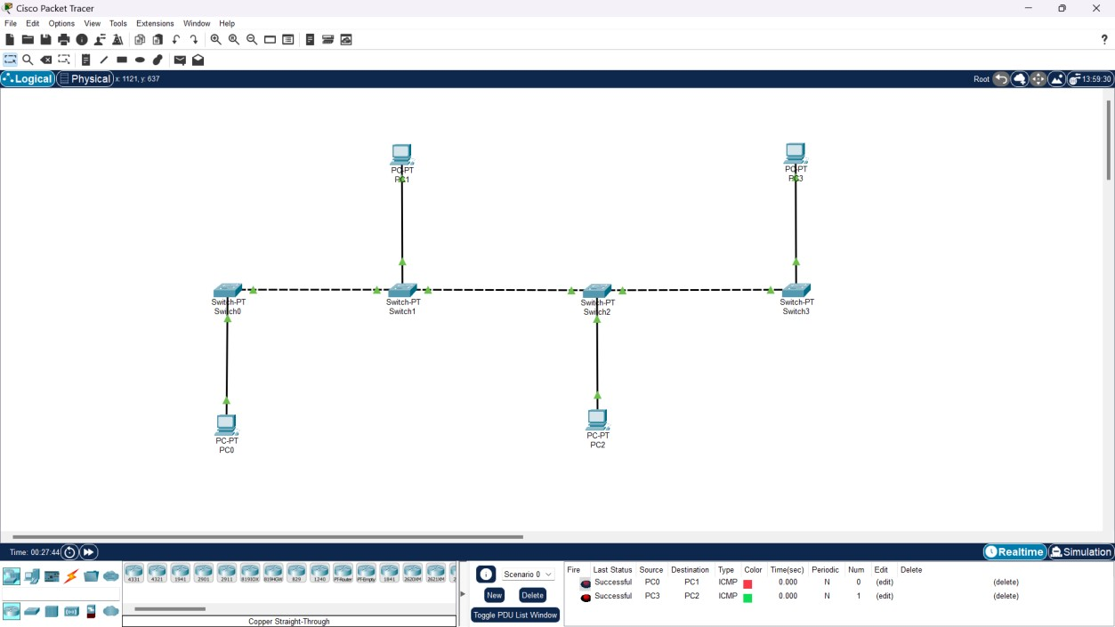

**STEPS:**

1. Open Cisco Packet Tracer: create a new project.
2. Add Devices: Drag and drop the required number of PCs onto the workspace.
3. Connect Devices: Use the "Automatic Connection" tool (lightning bolt icon) to connect all PCs in a linear fashion. This simulates the bus cable connecting each device.
4. Configure IP Addresses: Assign IP addresses to each PC. For example:
   * PC0: 192.168.1.1
   * PC1: 192.168.1.2
   * PC2: 192.168.1.3
   * PC3: 192.168.1.4
   * Subnet Mask: 255.255.255.0
5. Verify Connectivity: Use the ping command from one PC to another to ensure connectivity. For example, from PC0, ping PC1 using ping 192.168.1.2.

**RING TOPOLOGY:**

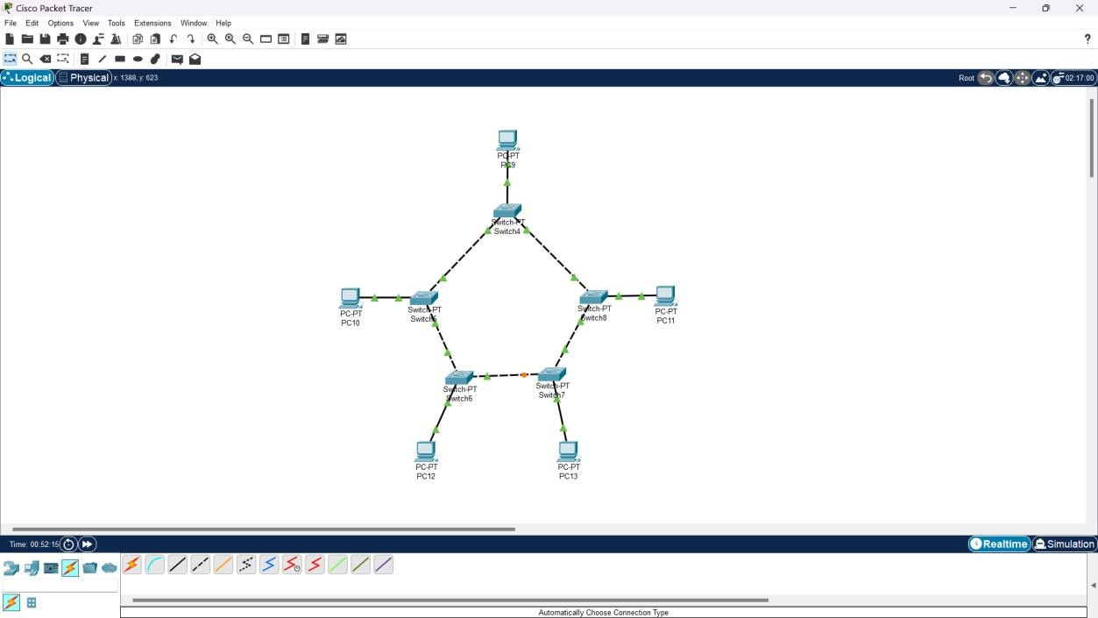

**STEPS:**

1. Open Cisco Packet Tracer: Start a new project.
2. Add Devices: Place the desired number of PCs in the workspace.
3. Connect Devices: Connect each PC to the next in a circular manner using the "Automatic Connection" tool. Ensure the last PC connects back to the first to complete the ring.
4. Configure IP Addresses: Assign IP addresses similar to the bus topology.
5. Verify Connectivity: Use the ping command to test connections between PCs.

**MESH TOPOLOGY:**

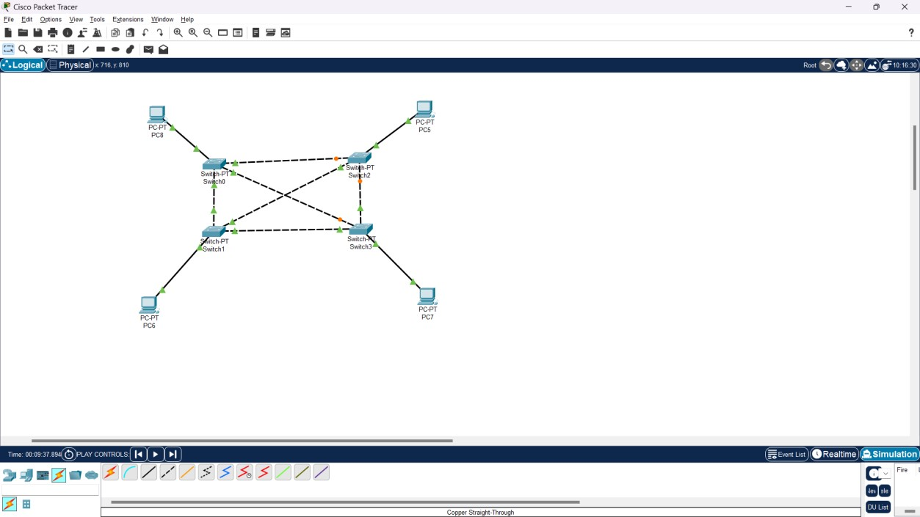

**STEPS:**

1. Open Cisco Packet Tracer: Create a new project.
2. Add Devices: Place the required number of PCs and switches in the workspace.
3. Connect Devices: Connect every PC to every other PC using the "Automatic Connection" tool. This creates a fully connected network.
4. Configure IP Addresses: Assign unique IP addresses to each PC.
5. Verify Connectivity: Test connectivity by pinging each PC from every other PC.

**TREE TOPOLOGY:**

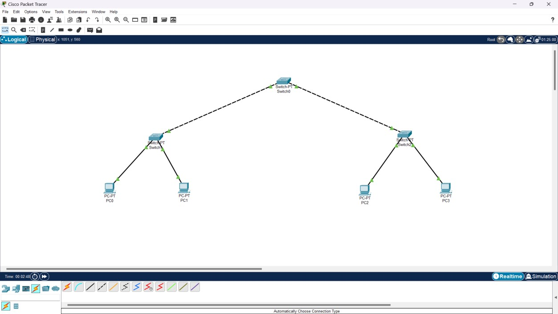

**STEPS:**

1. Open Cisco Packet Tracer: Create a new project.
2. Add Devices: Place a root switch, several intermediate switches, and end devices (PCs) in the workspace.
3. Connect Devices: Connect the root switch to the intermediate switches, and then connect the intermediate switches to the PCs.
4. Configure IP Addresses: Assign IP addresses to each device, ensuring they are in the same subnet as their respective switch.
5. Verify Connectivity: Test the network by pinging devices across the tree structure.

**HYBRID:**

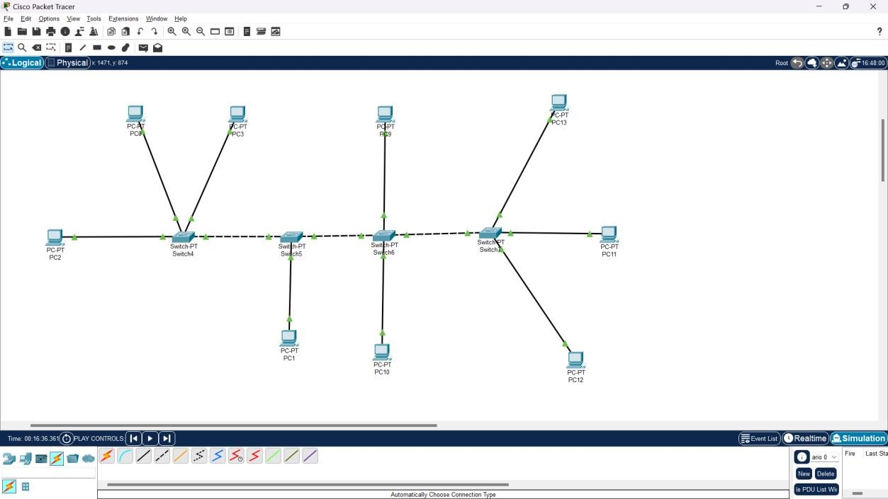

**STEPS:**

1. Open Cisco Packet Tracer: Start a new project.
2. Add Devices: Drag and drop a mix of devices (PCs, switches, and routers) into the workspace.
3. Connect Devices: Create a combination of topologies (e.g., star and bus) by connecting devices accordingly. For instance, connect multiple PCs to a switch, and then connect that switch to a router.
4. Configure IP Addresses: Assign IP addresses based on the subnetting scheme.
5. Verify Connectivity: Use the ping command to check connections across different segments of the network.